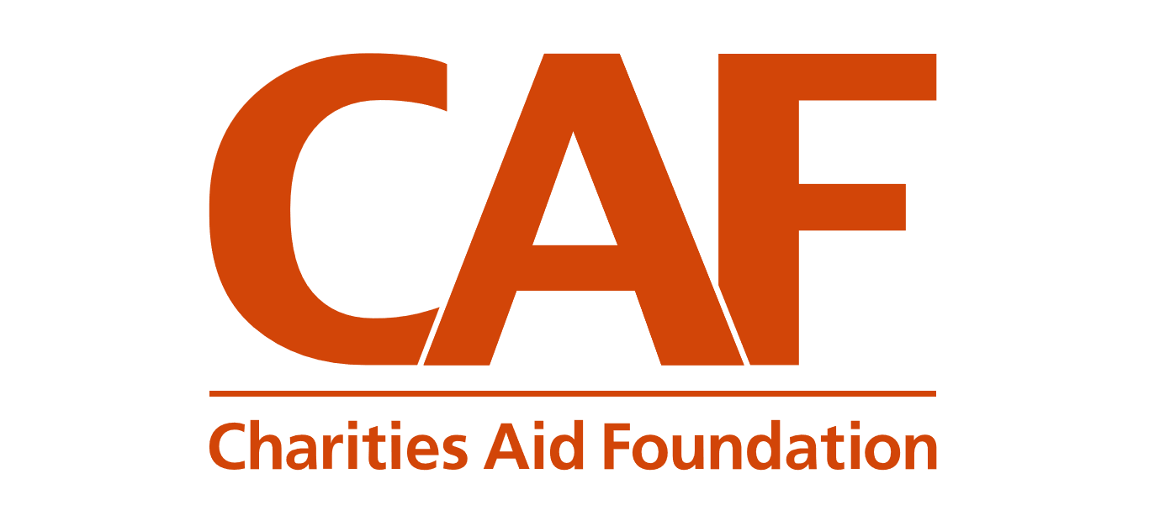
#GivingTuesdayNow
Tuesday 5th May 2020 – A response to Coronavirus

#GivingTuesdayNow is a global day of unity in response to Coronavirus. A day where we can all come together to recognise, celebrate and give thanks for the incredible outpouring of compassion we have witnessed during this crisis.

We want everyone to show their gratitude for what so many have been doing over the past few weeks and months. How people have put kindness and compassion first, how they have reached out to support our neighbours and our communities.

It is a chance to say thank you to those who have kept us going through this challenging time, an opportunity to show our appreciation for all NHS workers including medical staff, cleaners, porters, laundry staff and caterers, all food chain staff, delivery drivers, bin collectors, public transport workers, teachers, care workers, milk and post men & women, emergency services, community volunteers, workers making PPE, neighbours and of course charities!

On 5 May, we are asking people to share a message of thanks on social media, or a heart in their front window, as a sign of gratitude to all essential workers supporting our communities. You can even combine these two activities and share a photo of your heart with a personal message on social media. And of course, we ask, if people are in a position to give, then to make a donation on the day to a charity or a fund to help those affected.

#GivingTuesdayNow will be also be a day to celebrate and support the charities who have stepped up and reached out to support our family, friends and communities during this difficult time and who are continuing with their important work in challenging circumstances. They need us now to help make sure they will still be there in the future.

It will be a time to say thank you to those whose focus during this crisis has been on how they could help. If you would like to support the Faith Network for Manchester you can at https://www.justgiving.com/crowdfunding/faithnetwork4manchester . Of course other charities are available to support but we would be grateful for any donations at this time.

