

|  |
| --- |
| **JANUARY 2021**  **Services online at present** **ALL ARE WELCOME** **WITHIN THE CIRCLE OF LOVE** |
| Unitarians are a religious denomination that believe in a united world community, justice, peace and compassion. |

**MINISTER’S LETTER**

Dear friends

Welcome (almost) to 2021! It’s still a week away at the time of writing, but I would imagine a lot of people are getting quite excited about its arrival, if only to see the back of 2020.

2020 has been such a rough year in so many ways, and while many of us will have been cushioned from a lot of hardship this year, many others of us have struggled with financial difficulties, illness or bereavement. And for those reasons and many more we will be glad to move forward.

But we shouldn’t turn our backs on it all together. Because there were some good parts to 2020 that shouldn’t be dispensed with so quickly. We saw whole communities immediately spring into action to protect and care for their most vulnerable members. We saw individuals do all sorts of projects to raise money for charity. We saw local businesses respond in all sorts of creative ways to dire situations to continue serving their customers while keeping everyone safe. We witnessed the absolute dedication and self-sacrifice of medical and caring professionals – and while they should never have been put in such desperate conditions, their unconditional love for their patients and residents and clients was an inspiration and a blessing.

We also saw the possibility for environmental healing – when planes were grounded, and cars parked up, the air began to clear, and literal visions of hope could be seen for hundreds of miles. We saw the possibility for a slower life, based less on productivity and more on community and creativity.

While we talk about “getting back to normal”, we need to ask ourselves just what we mean by that “normal”. Do we mean unbridled pollution and consumption again, and exhausting work schedules? Or is it primarily the hugs and handshakes, shared meals, and singing that we want back? There is going to be a lot of talk about economic recovery in the coming years, paying back the Treasury for the billions spent in furlough schemes etc – but we need to make sure that financial “recovery” does not come at the cost of the new wealth of community spirit that we have discovered, or through increased austerity that hurts most those who are already the poorest and hardest hit.

As for moving forward, we need to take with us the love, the creativity, the compassion, the spirit of community that showed its true strength right from the beginning of the pandemic. We need to value our key workers, those who heal us and feed us and keep our infrastructure working, doing all the gritty, down-to-earth jobs, and make sure they know both from our words and our actions how much they are valued – and I don’t mean doorstep clapping! Though it had its place.

For me, Howard Thurman always has the last word on December and all its festivities, and speaks to what our goals for 2021 should be, so I leave you with his words.

And as for after Christmas – what then?

When the song of the angels is stilled,  
when the star in the sky is gone,  
when the kings and princes are home,  
when the shepherds are back with their flocks,  
the work of Christmas begins:

to find the lost, to heal the broken,  
to feed the hungry, to release the prisoner,  
to rebuild the nations, to bring peace among the people,  
to make music in the heart.

With love and blessings, Rev Anna

**CHURCH SERVICES**

At the moment, church services are still being held online (Zoom and YouTube) or being emailed / posted out as word documents, and the church building is closed. There are many who expect a further national lockdown to happen, which will equally impact on our willingness or ability to hold in-person services.

A committee meeting is scheduled for Sunday 10th January, at which a decision will be taken as to how to proceed for January and into February, and an email will sent out as soon as possible to let you know what the plans are.

Please bear with us as we do our best to understand the various regulations, and to keep you as safe as possible when we do get back to the building.

**MONTON UNITARIAN CHURCH ON THE INTERNET**

Website: [www.ukunitarian.org.uk/monton](http://www.ukunitarian.org.uk/monton)

Twitter: @montonunitarian

Instagram: [www.instagram.com/montonunitarians](http://www.instagram.com/montonunitarians)

Facebook page: <https://www.facebook.com/montonunitarians/>

YouTube: Monton Unitarian Church – for all our ‘lockdown’ services.

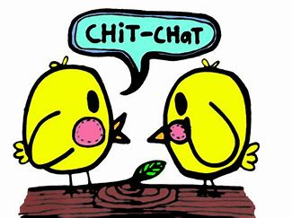

**VISITS FROM THE MINISTER**

Please do give me a call any time you fancy a chat – you don’t need to wait for me to call you to see how you are! If I don’t immediately answer, please just leave me a message and I’ll get back as soon as I can.

And while I’m still not able to visit in quite the same way as I would like, we can still arrange meetups – we just have to be a bit inventive! Again, just give me a buzz, or drop me an email!

. 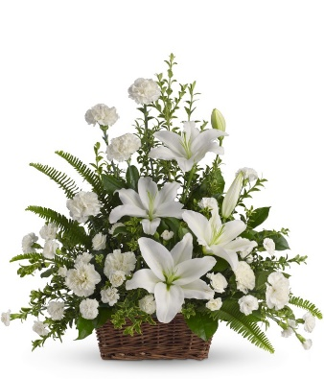

**JANUARY FLOWERS**

|  |  |  |  |  |  |  |  |  |  |  |  |  |  |  |  |  |  |  |  |  |  |  |  |  |  |  |  |
| --- | --- | --- | --- | --- | --- | --- | --- | --- | --- | --- | --- | --- | --- | --- | --- | --- | --- | --- | --- | --- | --- | --- | --- | --- | --- | --- | --- |
| |  |  | | --- | --- | | 3rd | Mr G N Booth in memory of Mr & Mrs Booth | |  |  | |  |  | | 10th | Mr & Mrs A Taylor in memory of Vicky & Frank Meeghan | |  |  | |  | Mr G Knight in memory of Shirley a loving Wife | |  | & Mother | |  |  | | 17th | Mavis Sumner in memory of her Daughter Julie | |  |  | | 24th | In memory of late Church members | |  |  | | 31st | Mrs A Brown in memory of her Husband Will (My Lad ) | |  |
|  |  |
| As explained in the previous newsletter, we no longer have regular fresh flowers in the church, and are therefore not taking payments from families for the mentions as above. But for now we still mention them so that the rest of us can hold them in prayers. |  |
|  |  |
|  |  |
|  |  |

**THE THREE KINGS REWRITTEN**

Epiphany, celebrated on 6th January, is the day set aside to commemorate the arrival of the magi, the wise men, to the stable in Bethlehem, following the birth of Jesus. The timing, of course, is completely cockeyed, as it would have taken them a a lot longer than two weeks to get there after the star appears!

Various songs have been written about the three kings, but R.G. Huff has written some new words which you may enjoy! And yes, you have to sing it to yourself! (Many thanks to David Coyle for sending this our way!)

We three kings are six feet apart.

We’ll Purell before we depart.

We’ve been tested as suggested.

Careful are we, and smart!

*O-oh… Do our masks go with our gowns?*

*Do these face shields hide our crowns?*

*We’ve had plenty twenty twenty!*

*Still we head t-ward David’s town.*

Melchior is now quarantined!

Stuck in Persia, or so it seems.

No more travel on a camel

Till there’s a good vaccine.

*O-oh… Do our masks….*

Balthasar has lost his taste.

Eating food is such a waste.

How disquieting, now he’s dieting:

Life now is slower-paced.

*O-oh… Do our masks…*

Caspar left the caravan.

He postponed his stargazing plan.

No more roaming, Caspar’s homing,

Scrubbing his reddened hands.

*O-oh… Do our masks….*

**TELLING OUR STORIES**

Some of you may have noticed that the calendar recently has been a little bit on the thin side! Well, here’s your chance to do something about that!

We’re asking you to get involved! And we have two options for you.

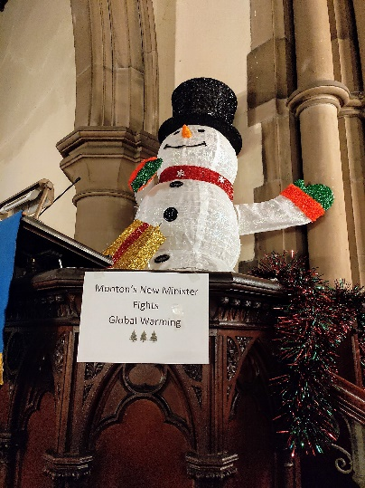One is to dig out any old photos of events in the church, whether personal e.g. weddings, or even baptisms, or social (old Christmas fayres, or a garden party), and write a short article to go with it, telling us what the event was, who was there, what you remember about it. These will feature in the newsletter, and also head over into our new website that is being built. So, for example, who could forget our dear stand-in winter-minister, proudly occupying the pulpit during last year’s Christmas Tree Festival!

The second is to send us a photo of yourself, and write a “Getting to know me” article – while folk who have been coming to church for a long time may know each other, there are plenty of newer folk coming who don’t have those backstories, and it would be lovely to share some of our stories to help people get to know each other better. So, a little bit of history, where you come from, maybe a bit about jobs, or travelling that you’ve done, and most importantly how you came to Monton Unitarian Church, and what’s kept you with us.

So please! Take the opportunity over the Christmas break to have a root around in your photo albums, and tell us some stories about Monton Church past and present – and tell us about yourselves! Send them to Debbie (her telephone number is at the back to ask for her post or email address), or send them to me on [minister@montonunitarianchurch.com](mailto:minister@montonunitarianchurch.com) and I can forward them to her.

And then look forward to seeing your story in print!

**GENERAL DATA PROTECTION REGULATIONS**

Yes, it’s that’s again. We are reviewing our data protection again, and tightening it up, as we have been a bit lax in recent years.

Many of you receive this newsletter because you have come to us for a wedding or a baptism, and will have been asked at the time if you wished to receive the newsletter. With the regulations being what they are now, we need to have written evidence of that agreement stored and accessible at the church.

So I have attached with this newsletter a data protection form, and would ask you please, if you wish to continue to receive the newsletter, and notifications about social events, or fundraising activities, or other news, please complete the form and return it to me, either by email, or by post. If you do not wish to keep getting the newsletter, please do also let me know, either by email, or just drop me a text asking to be removed from the mailing list. Obviously, we hope you’ll all stay with us, but understand that situations change!

It is, however, very important that you send the form back if you do wish to continue, as if I have not received the form back by 31st March 2021 I shall be obliged to take you off the list regardless! You would always be welcome to ask to come back on, of course!

To send the form back by post, send it to:

Monton Unitarian Church

Monton Green

Monton

M30 8AP

Or by email to [minister@montonunitarianchurch.com](mailto:minister@montonunitarianchurch.com).

The forms shall only be seen by myself, acted upon, and then stored securely in our safe.

Thank you for your help in keeping us GDPR compliant!

**COURTSHIP ETIQUETTE FOR 2021**



**MAGAZINE**

If anyone would like to contribute any articles for the magazine, please send them to the editor by the second weekend of the month by post or by email. Please contact me by phone for email address. Thank you. Debbie.

|  |  |  |
| --- | --- | --- |
| **MINISTER** | Rev Anna Jarvis | 07769 038 773 |
| **CHAIR** | Mavis Sumner | 0161 281 0614 |
| **SECRETARY** | Rennie McFarlane | 07846 634361 |
| **TREASURER** | Michael Couser | 0161 969 2124 |
| **ORGANIST** | Peter Collier | 0161 281 2502 |
| ENVELOPES AND SUBSSECRETARY | Michael Couser | 0161 969 2124 |
| **LETTINGS** OFFICER | Rev Anna Jarvis | 07769 038 773 |
| **MAGAZINE**  **EDITOR** | Debbie Hulme | 0161 707 1921 |
| **WEDDINGS &**  **BAPTISMS** | All enquiries | 07769 038 773 |
|  |  |  |

MONTON CHURCH is open to all who wish to worship with an open mind, in a spirit of freedom, reason and tolerance. No doctrinal tests are imposed on anyone. Rather, each person is encouraged to develop his or her own faith. Our Congregation is affiliated to the General Assembly of Unitarian and Free Christian Churches.