

|  |
| --- |
| **MARCH 2021**  **Services online at present** **ALL ARE WELCOME** **WITHIN THE CIRCLE OF LOVE** |
| Unitarians are a religious denomination that believe in a united world community, justice, peace and compassion. |

**MINISTER’S LETTER**

Dear friends

A couple of weeks ago we entered Lent – and Easter is just over a month away. This time last year we were just beginning to grasp the fact that there was a nasty virus around, but I don’t think any of us had the slightest inkling of what a difficult journey was ahead of us. It’s been a very rocky road – isolation, fear, anger, grief and overwhelming tiredness of spirit and of body. So many people who were there at the beginning of the journey are no longer with us – others are but are struggling with long-term effects of the illness – young people among us may seem untouched but will carry long-lasting emotional scars. A long period of reflection is going to be needed to sort through what we’ve lost, what we’ve learned, and how we will move forward.

That theme of journeying and reflection runs through this period of Lent. The story of a man lost in a wilderness both physical and spiritual, searching his soul and his conscience to discern who he is, what he must leave behind, and where his path must lead, encapsulated in the mythical story of Jesus in the desert being tempted by Satan. But like all myths there are elements of truth, and lessons we can learn.

There will be things we have lost over this past year – time, holidays, rites of passage – connections with friends and loved ones, shared events. Hopefully for many of us there is still plenty of time to catch up on those, and to honour belatedly the events that need acknowledgement – but equally we know that for others, we have had to say goodbye, and there is no more catch-up time, and that pain will stay with us.

There will also be things we may wish to leave behind – some of our old ways of doing things, the old patterns of living, may no longer feel sustainable, and through the enforced slowing down, we may realise that there are better ways of living. That’s part of the learning – learning how our lifestyles may be damaging the world in more ways than we originally realised, learning how to change and to heal, learning how to create new, healthier relationships with each other and with the planet.

And moving forward. The way out of lockdown has been laid out, whether it happens at quite the speed we hope for or not. We shouldn’t rush it – that could be counterproductive – but we will be looking forward, seeing glimmers of hope for renewed contact with people, and quite literally brighter days!

The church is going to be working out its way forward too – when we can re-open for worship safely, when the hall can begin to operate again – and oh, when we can have our coffee mornings again! I hope you can come along and join us when we do, although I know that you will need to find your own speed for things as well. We look forward to welcoming you just as soon as we can!

With love and blessings, Rev Anna

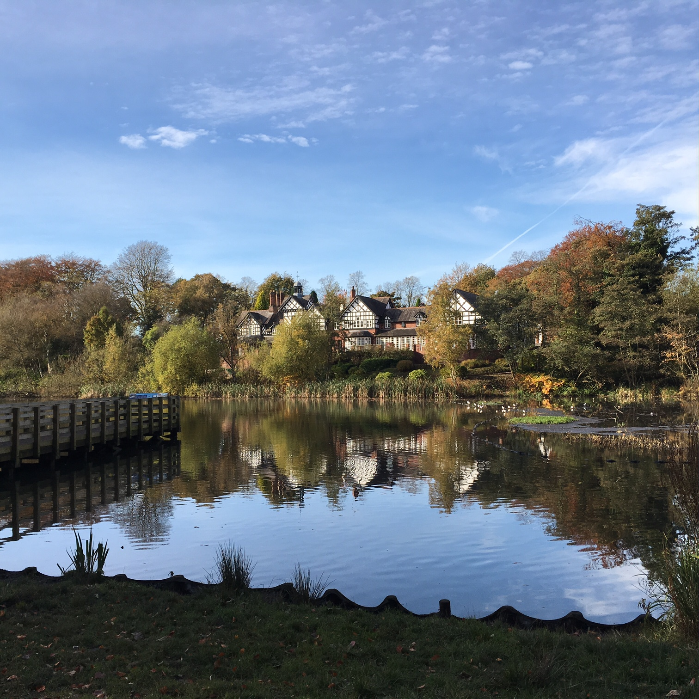

**A LOCKDOWN WALK**

A pink bin, a brown bin on the pavement, a lady with two children passes, the remains of a plastic bin sack, the Church comes into sight. I cross the road, approach the walk way and sit on a form, two ladies arrive with shopping bags, chatting to one another, they use an adjacent form. A man with a dog, a cyclist passes, a weak pale winter sun, the 33 bus turns onto Parrin Lane, it is 14.28 hrs. I walk up the slope and on to the path, a clump of green spear headed Daffodils on the verge, further along more clumps appear. Another cyclist passes, the sun reflects light on the trees, making lines across the path. The brook on the golf course, is high and full due to heavy rainfall. A lost glove hangs on the branch of a small Beech tree. A runner passes, two ladies wearing masks and hats, two men with a brown and white dog. I pause, a speckled Thrush hops along the mud and perches on a small wooden log. A pool of water, some Laurel bushes, I pass the green railings as I approach the old Worsley Station, a discarded coffee cup, on under the tunnel, some children having fun, jumping over a pool of water.

I proceed up some steps, pass a Childrens Play Area, on to Worsley Dam, a child is happily feeding the Swans, Ducks and Sea Gulls, her mother close by.

I walk back to Worsley Village, over the canal bridge, take a rest on a form, the trees in winter black against the pale blue, grey white sky, and walk to Monton along the canal path.

Written and submitted

By Irene Hitchcock



**MARCH FLOWERS**

|  |  |  |  |  |  |  |  |  |  |  |  |  |  |  |  |  |  |  |  |
| --- | --- | --- | --- | --- | --- | --- | --- | --- | --- | --- | --- | --- | --- | --- | --- | --- | --- | --- | --- |
| |  |  | | --- | --- | | 7th | In memory of late Church members | |  |  | | 14th | Mrs Tabor in memory of Mr & Mrs Williamson | |  |  | | 21st | Mrs M C Harwood in memory of Mr & Mrs N Davenport | |  |  | | 28th | In memory of late Church members | |  |  | |  |  | |  |
|  |  |
| As explained in the previous newsletter, we no longer have regular fresh flowers in the church, and are therefore not taking payments from families for the mentions as above. But for now we still mention them so that the rest of us can hold them in prayers. |  |

**TELLING OUR STORIES**

Hi All



My name is Pam Ward and I joined Monton Church just over 4 years ago.

I have had very mixed experiences of religion through the years.  My mum was a committed Christian (Church of England) and my dad a committed Atheist!  I was never pushed into going to Church, but started going to Eccles Parish Church with my mum when I was young where I attended the Sunday School – until I discovered then benefits of staying home and having Dad bring us bacon butties in bed!!  In my teenage years I started attending Monton Methodist Church (and their excellent Youth Club!) and became a member after an enlightening trip to see Billy Graham.  In my 20s however, I became disenchanted with the Church and although I did occasionally look for spiritual guidance I never quite found the right place for me.

 It was after a huge change in my life that I found Monton Church.  I lost my beloved Dad, then 8 years later lost my mum.  I left my job (with a good case for Constructive Dismissal) and was in a very dark place.  After 6 months at home taking my frustrations out on the house (in the form of renovations and decorating!) I decided to do what I had always wanted to do – I became a Carer, a job I love and which gives me immense pleasure and satisfaction.

I had previously spoken to our Minister, Anna, at the local Community Association meetings and at one particular meeting, she told us about the Blue Christmas service happening that December.  I decided to go along and although it was in many ways a difficult service for me, afterwards Anna introduced me to Alan and Gloria, as well as other members of the church, and I left feeling very welcomed and loved.

The experience also left me wondering about the Church and Unitarianism, about which I did not have a clue!   I attended the next service the following Sunday and met more of the congregation and was again welcomed with open arms (and lots of coffee and cake!), and somehow I knew that this was my spiritual home – a place of love, kindness, hope and sometimes sanctuary, a place where I don’t have to conform to religious views but can learn about other religions and other people’s views in an atmosphere of love and respect, a place where  I can listen and be heard without criticism, derision or disrespect.  And that is a rare thing these days!

In 2019 I got engaged to my lovely fiancé Dave and although he was amazed that I, a confirmed non-churchgoer, was regularly attending and very much involved with Monton Church, he agreed to come to a service with me one Sunday and is also now very much a part of the Church. We hope that Anna will marry us very soon (although we have already had to postpone twice due to the COVID-19 epidemic!),

In 2020 I completed the Unitarian Worship Studies Foundation Course and have been lucky enough to lead a few services – hopefully after the current Lockdown, I will be able to complete the Assessment part of the course and become a recognised Worship Leader.   In addition, I was fortunate enough to be elected onto the Church Committee last year and very much hope I can use this position to help the Church and its congregation to grow and continue its wonderful work.

Wishing you all love, peace and happiness.

Pam x

**MONTON UNITARIAN CHURCH ON THE INTERNET**

Website: [www.ukunitarian.org.uk/monton](http://www.ukunitarian.org.uk/monton)

Twitter: @montonunitarian

Instagram: [www.instagram.com/montonunitarians](http://www.instagram.com/montonunitarians)

Facebook page: <https://www.facebook.com/montonunitarians/>

YouTube: Monton Unitarian Church – for all our ‘lockdown’ services.



**GENERAL DATA PROTECTION REGULATIONS**

This is the final call for the data protection forms – enclosed with the paper version, and as a separate file on the email version. Please do send them in if you haven’t already – the mailing list will be amended according at the end of March, and if I do not have your form, you will no longer receive any communications from us.

To send the form back by post, send it to:

Monton Unitarian Church

Monton Green

Monton

M30 8AP

Orby email to [minister@montonunitarianchurch.com](mailto:minister@montonunitarianchurch.com).

The forms shall only be seen by myself, acted upon, and then stored securely in our safe.

Thank you for your help in keeping us GDPR compliant!

**MAGAZINE**

If anyone would like to contribute any articles for the magazine, please send them to the editor by the second weekend of the month by post or by email. Please contact me by phone for email address. Thank you. Debbie.



|  |  |  |
| --- | --- | --- |
| **MINISTER** | Rev Anna Jarvis | 07769 038 773 |
| **CHAIR** | Mavis Sumner | 0161 281 0614 |
| **SECRETARY** | Rennie McFarlane | 07846 634361 |
| **TREASURER** | Michael Couser | 0161 969 2124 |
| **ORGANIST** | Peter Collier | 0161 281 2502 |
| ENVELOPES AND SUBSSECRETARY | Michael Couser | 0161 969 2124 |
| **LETTINGS** OFFICER | Rev Anna Jarvis | 07769 038 773 |
| **MAGAZINE**  **EDITOR** | Debbie Hulme | 0161 707 1921 |
| **WEDDINGS &**  **BAPTISMS** | All enquiries | 07769 038 773 |
|  |  |  |

MONTON CHURCH is open to all who wish to worship with an open mind, in a spirit of freedom, reason and tolerance. No doctrinal tests are imposed on anyone. Rather, each person is encouraged to develop his or her own faith. Our Congregation is affiliated to the General Assembly of Unitarian and Free Christian Churches.