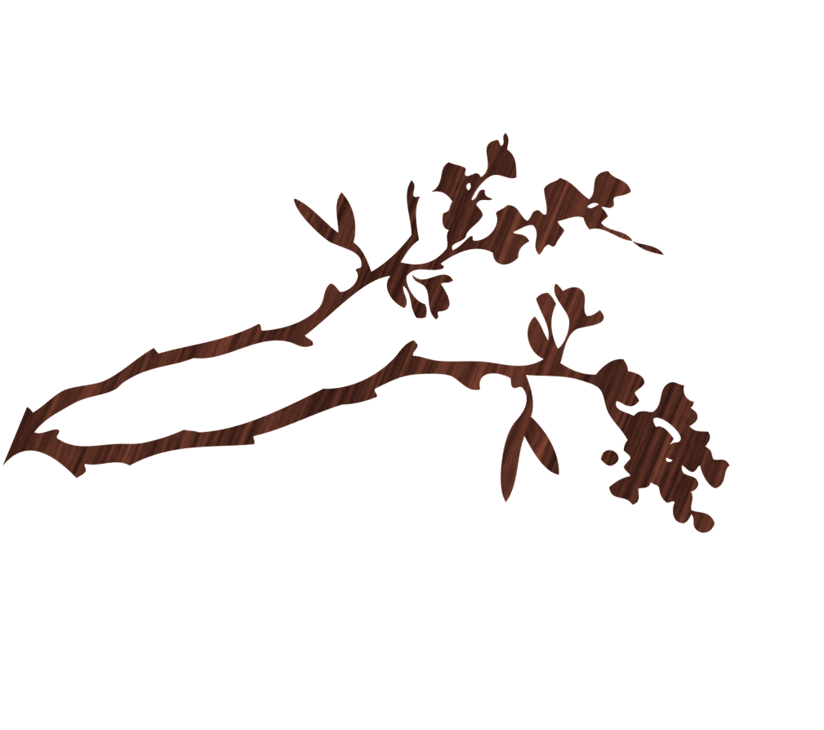
Joy Singing And Silence
for more information contact: Rev Danny Crosby on 07908894049

Singing Meditation
Together in Sound & Silence
Tuesday 17th August at 7pm
School Room, Dunham Road Unitarian Chapel
Sylvan Grove, altrincham, WA14 4NU
Outdoor in the chapel Gardens.
An evening of simple song chants from a variety of world traditions interspersed with periods of meditative silence. This is a simple practice that anyone can engage with. You do not need to be an experienced meditator or singer. In fact many people who thought that either singing or meditation was beyond them have found their voice and their space in this simple joyfilled time together. Please feel free to bring any song chants you know and or musical instruments to enhance the energy…

