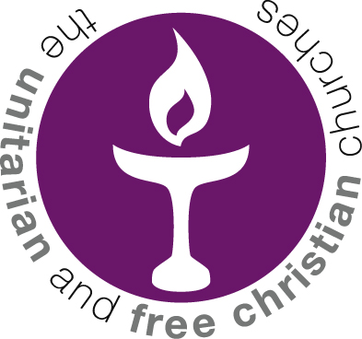
Unitarian College
Growing our faith from the inside

Course in conducting Rites of Passage

Increasingly Unitarian communities are being asked to host Rites of Passage. From weddings, blessings, memorial services and child welcomings and other ceremonies. Unitarians bring a unique and individualised flavour to these important life events.

Unitarian College is delighted to announce we will be offering a course in how to lead these ceremonies to a high standard.

The course will be offered in a blended way, through meetings on Zoom followed by a residential weekend at the Luther King House, Manchester. http://www.lutherkinghouse.co.uk/

The relevant dates are:

Zoom meetings – Thursday 9th June 7pm – 9pm and
Thursday 16th June 7pm – 9pm

Residential weekend at The Luther King House:
Friday 1st to Sunday 3rd July 2022

The course will be led by Rev Ant Howe, Rev Michael Dadson and Rev Melda Grantham of Unitarian College along with other visiting experts.

Places are limited and will be offered on a first come, first served basis as payments are received. The cost of the course is £300. This includes all tuition along with food and accommodation at The Luther King Centre (but not travel costs). Participants are encouraged to approach congregations and Districts to help with funding. If you would like to take the course but cannot afford the fee, please contact us and we will see what we can do to help.

If your congregation is affiliated to the North West Provincial Assembly, you will be entitled to a £150 subsidy. To book your place and find out more, please email
HMason@unitarian-college.org.uk or send an enquiry via the Unitarian College website.

